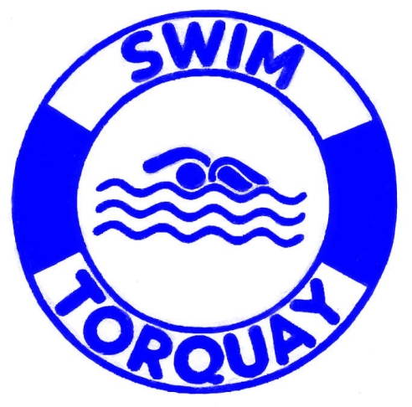
Swim Torquay Ltd
Company No.1214211 Registered in England
Directors: R.G.W.Margetts, K. Merrick, P.Tysoe, L.Pitts
Registered Charity No.272712

Membership Registration Form

Full Name:
Address: Post Code:
Email:
Contact No. Mobile No.

Annual Fee
Adult Annual Membership Fee £330
OAP Annual Membership Fee £300

Monthly Fee
Adult Annual Membership Monthly Fee £33 pcm
OAP Annual Membership Monthly Fee £27.50 pcm

(please tick appropriate boxes)

Total Price of Membership: £ Annual/pcm
(delete as appropriate)

• This membership will entitle the user to unlimited swims during all General Public Sessions
• All memberships are subject to Swim Torquay Ltd Membership Rules. Any breach of these rules may result in cancellation of the membership, without refund.
• Personal information in this form, will solely be used by Swim Torquay Ltd. Swim Torquay may use the information to make you aware of other offers available.

Customer Agreement

I have read and agree to all the terms and conditions set by Swim Torquay Ltd. I also agree to abide by Swim Torquay Ltd Membership Rules.

Customer Signature |  |  |  |  |  | Date
Staff Name |  |  | Staff Signature |  |  |  |  |  | Date
Annual payment received: £ |  |  |  | Print & attach receipt:
First monthly payment received: |  |  |  | Cash: |  |  |  | Card:
Standing order form completed |  |  |  | Date SO to start
The guarantee should be detached and retained by the payer.
- This Guarantee is offered by all banks and building societies that accept instructions to pay Direct Debits.
- If there are any changes to the amount, date or frequency of your Direct Debit Swim Torquay Ltd will notify you 10 working days in advance of your account being debited or as otherwise agreed. If you request Swim Torquay Ltd to collect a payment, confirmation of the amount and date will be given to you at the time of the request.
- If an error is made in the payment of your Direct Debit, by Swim Torquay Ltd or your bank or building society, you are entitled to a full and immediate refund of the amount paid from your bank or building society
- If you receive a refund, you are not entitled to, you must pay it back when Swim Torquay Ltd asks you to.
- You can cancel a Direct Debit at any time by simply contacting your bank or building society. Written confirmation may be required. Please also notify us.

